How to Write your Symposium Paper for 2SSSC’24

First A. Author1,2,*, Second B. Author2, and Third C. Author2
NO MORE THAN 03 (Three) CO-AUthors.
- Affiliation (Author): dept. name of organization name of organization, acronyms acceptable
City, Country
- Affiliation (Author): dept. name of organization name of organization, acronyms acceptable
City, Country
-e-mail address if desired
-e-mail address if desired

ABSTRACT (1,000 characters)
This text provides formal rules for submitting a paper to the 2sd Symposium on Smart and Sustainable Cities 2SSSC’24. Communications selected by the Symposium scientific committee will be compiled within Symposium proceedings distributed to participants at the beginning of the Symposium, and available onligne. The communications size should be comprised between 10,000 and 12,000 characters (spaces included), means 6-8 pages, and conform to the formal rules of the current template (we strongly recommend authors to use it as a direct support to write their communication).
Each communication will be composed of a summary, 3 to 6 keywords, an introduction setting the communication aim and replacing it within its scientific domain, sections presenting the communication ideas and main results related to the concerned topic, as well as around approximately twenty references bibliography.
KEY WORDs (3 to 6 key words)
Introduction ; proceedings ; artificial intelligence ; communication ; Template ; instructions
- INTRODUCTION
The objective of this template of communications is to facilitate the work of the Scientific Committee of the 2SSSC’24 Symposium in selecting communications and the Organizing Committee to make them available to the participants at the opening of the Symposium. It is also important that the comprehension of researchers from different disciplines is as easy as possible. This implies a template presentation, as clear as possible; researchers from various disciplines can understand that. This document gives formatting instructions for authors preparing extended abstracts in Microsoft Word for publication in the program and proceedings for 2SSSC’24. For this first edition of the International Symposium on Artificial Intelligence in Renewable Energetic Systems, the organizing committee proposes this type of template which will be slightly modified in the next editions and which will take into consideration all your remarks and criticisms to produce a template in the image of the Symposium and its progress. This will allow a much more timely publication of the Symposium proceedings, and should make it easier for preliminary work presented at the Symposium to be completed and submitted to refereed journals as full publications following the Symposium. The authors are asked to follow the instructions given in the document when preparing their abstracts to assist the Local Organizing Committee with the preparation of the Symposium program and proceedings and to allow efficient reviewing of submissions by the Scientific Organizing Committee. You can use this document as both an instruction set and as a template into which you can type or paste your own text, this electronic document is a “live” template and already defines the components of your paper [title, text, heads, etc.] in its style sheet.

- Recognized rules for papers submitted for communication in 2SSSC’24
- Language
In accordance with the international standard, the communication should be written in English.
- Layout
Papers must be submitted on the website in Word format, portrait A4. They should not be subject to changes in the size of the page given by default by Word (margins: 2.5 cm high, bottom, right, left). All the text is justified, in the dimension given by default by Word; only the abstract is the subject of a particular positioning in the document (as in this document: +2 cm on the left, -2 cm on the right).
- Police and Fitness
The font is Times New Roman 10 for the entire communication except for the title of the communication (Times New Roman 18), and for the coordinates of the authors at the first of the text (Times New Roman 9). The title of the paper is in bold, lowercase, with a "before text" spacing of 18 points and "after the text" of 6 points; The headings in the sections are in bold and uppercase, with a "before text" spacing of 12 points, and "after the text" of 6 points; The sub-headings, if any, are in bold, lowercase, with a 12-point spacing before the text. Apart from the headings of the sections, capital letters are used only for the beginning of the sentence and for the first letter of the proper names (do not write the proper names entirely in uppercase). In addition to the forms required for titles and subheadings (bold), for book titles and scientific journals (italics), and in addition to the usual automatic format of url, we recommend to the authors an absolutely minimal use of formatting (Bold, underlined, italics ...). Similarly, the use of chips and numbers should be as sparing as possible.
- Structure of the text
The paper contains a summary of approximately 1,000 signs, followed by key words (from 3 to 6 maximum), a short introduction that presents the purpose of the text and places it in the scientific context of the authors. It will be organized around sections that will present the main results and the contributions of the communication to the theme to which it relates. The bibliographic references of the text are placed at the end of the text; they should not exceed thirty references.
- Maps, figures and tables
The maps, figures and tables are placed after the paragraph that makes explicit appeal to them; This call takes the following form: (Map [number of map], (Fig [number of figure]) or (Tabl. [Table number]) The full title of the map, table or figure Is placed at the top of the document (Fig.1).Figures must be numbered using Arabic numerals. Figure captions must be in 8 pt. Regular font. Captions of a single line (e.g. Fig. 1) must be centered whereas multi-line captions must be justified (e.g. Fig. 1). Captions with figure numbers must be placed after their associated figures, as shown in Fig. The proceedings of the 2SSSC’24 made available to participants on the day of the Symposium will be printed in black and white. If the provided cards are in color, it is important to check that their reproduction in black and white is legible.
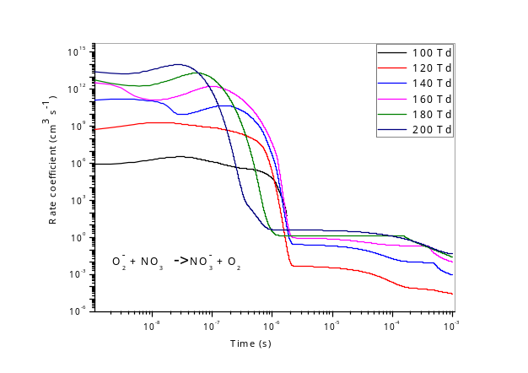
Fig. 5. Time evolution of rate coefficient of reaction : $O_{2}^{-}+{NO}_{3} {→NO}_{3}^{-}+O_{2}$
for different reduced electric fields [100 - 200 Td].

- Standard bibliographic references(a maximum of twenty)
For scientific articles: name, initial of first name, year, title of article, name of the journal in italics, number (volume if applicable), publisher, place of publication, pp.
For book chapters: name, initial of first name, year, title of chapter, in [name, initial of first name], name of book in italics, editor, place of publication, pp.
For the proceedings of scientific colloquiums published: name, initial of first name, year, title of the communication, Proceedings of the Symposium [specify theme, organizer, place and date of the Symposium] Edition, pp.
For works: name, initial of first name, year, book title in italics, publisher, place of publication, pages. All of these references are referred to in the text of the communication as follows: in brackets (name of the author or authors year) when the reference is not included in a proposal; by putting only the year in brackets when the reference to the authors is included in a proposal. The 2SSSC’24 symposium draws on the example given by Nam, T. and Pardo (2011).
- Footnotes
They should be limited as much as possible. The maximum is, for each page, four lines at the bottom of the page. The best thing is to have none. Authors' contact details. At the beginning of the communication are indicated: the first name and in bold the names of the authors; Then on another line their main institutional connection; then on a last line their e-mail address.
- Recommendations to the authors on the Symposium website
All recommendations to authors and up-to-date Symposium information will be available at http://www.s3c.archeditech.org
- CALENDAR
• Submission of proposals for communication must be made by September 30, 2024, exclusively via the website https://www.s3c.archeditech.org/submission-paper
• The scientific committee's reply to authors will be given electronically in November 10, 2024.
• A collection of selected papers will be distributed at the opening of the Symposium in electronic form.

- publications
After consultation with the 2SSSC’24 Symposium Scientific Committee, the Scientific Synthesis of the Symposium and a longer version of some of the papers may be the subject of another possible scientific publication in the form of a collective work or a special issue of journals, https://www.s3c.archeditech.org/publications . The organizing committee will return to the authors concerned to solicit from them this long version of their communication, in a format to be defined later.
REFERENCES (10 to 20)
- Nam, T. and Pardo, T.A., 2011, June. Conceptualizing smart city with dimensions of technology, people, and institutions. In Proceedings of the 12th annual international digital government research conference: digital government innovation in challenging times (pp. 282-291).

